MOBILE PHONES
1. Mobile phones.
- Have you got a mobile phone? Yes.
- Do you think mobile phones were a good invention? Yes.
- How many messages do you send/receive a day? Seventy I think.
- Have you got a special code? Can you give an example? No.

2. Can you understand the following messages:
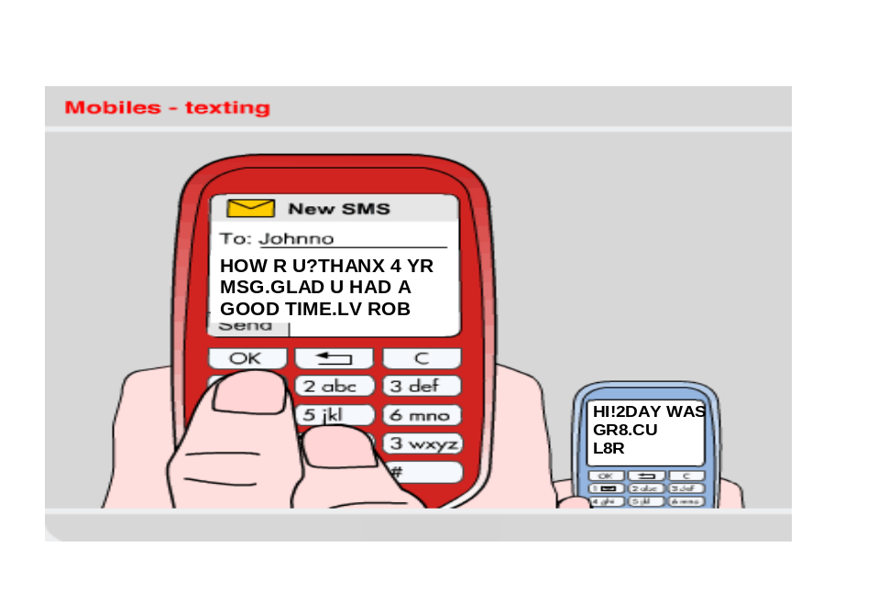
3. Match the abbreviation with its meaning:
R | later
U | for
THANX | today
4 | great
2DAY | you
MSG | are
GR8 | thanks
L8R | message
R= are
U= you
THANX= thanks
4= for
2DAY= today
MSG= message
GR8= great
L8R= later
4. Complete the table
ENGLISH TEXT | ENGLISH WORD | WORD IN YOUR LANGUAGE
COZ | because | porque
B4 | before | antes
txt | text | texto
2nite | tonight | Esta noite
M8 | mate | Colega
YR | year | Ano
NP | No problem | Sem problema
RUOK? | Are you ok?/ you are ok? | Voce está bem?
WKND | weekend | Fim de semana

5. What’s the message?
e.g. wer ru? = Where are you?
1) I’ll B l8. sry. I´ll be there. Sorry.
2) c u 2moro. See you tomorrow.
3) m 2 me too
4) I luv u. I love you.
5) btw between
6) lol League of Legends
7) Idk I don’t know
8) h&k hong kong
9) Asap fumaça.
10) w8 weight

